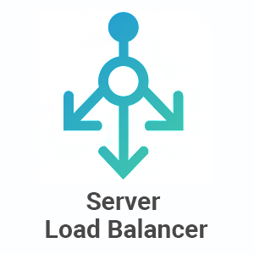

Cloud / Data Center Manager (Load Balancer (
  - YOUSSEF ESLAM
  - YOSSEF EL-SAYED
  - MOHAMMED YASSER
Operating systems | Load Balancer | 8/13/2026

INTRODUCTION

